OREGON POLICE DEPARTMENT

ANNUAL REPORT

2019

CITY OFFICIALS —
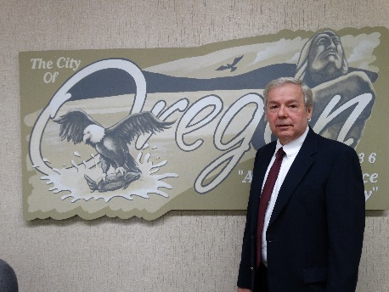

Mayor: Ken Williams

City Council: Terry Schuster, Kurt Wilson, Melanie Cozzi, Timothy Krug
City Clerk: Charlene Ruthe
City Attorney: Paul Chadwick
Chief of Police: Darin DeHaan
Current Staff
Darin DeHaan – Chief of Police - 23 Years of Service
Shawn Melville – Lieutenant - 22 Years of Service
Randy Cropp – Sergeant - 20 Years of Service
Joe Brooks - Sergeant - 17 Years of Service
Matt Kalnins – Patrol Officer - 13 Years of Service
Tad Dominski – Corporal - 5 Years of Service
Kristine Tesnow – 1 Year - Resigned
Josh Lee – 1 Year
Maison Crawford – New Hire
Brian Ketter – Part-time Officer - 7 Year of Service
Adam Frisbie – Part-time Officer – 2 Years of Service
Kenneth Yingling – Part-time Officer - New Hire
Mary Elliott – Administrative Assistant - 22 Years of Service
The City of Oregon Mission Statement

To foster an environment of economic growth and opportunity through effective partnerships with our citizens, businesses, and visitors while maintaining a high standard for quality of life in a progressive community that embraces our heritage.

Oregon Police Department Mission Statement
Our mission is to maintain peace and public order by providing high quality police services that are responsive to the needs of the community, We protect life and property by apprehending those who commit criminal acts, by developing partnerships to prevent, reduce, or eliminate neighborhood problems, and by providing police services that are fair, professional, and respectful of the dignity of all individuals.

Table of Contents
LETTER FROM CHIEF OF POLICE 4
BUDGET FISCAL YEAR 2020 5
OPERATIONAL COST OVERVIEW FISCAL YEAR 2020 6
DEPARTMENT ORGANIZATIONAL CHART 7
EMPLOYEES 8
ACADEMY GRADUATION 8
NEW EMPLOYEES 8
PART-TIME OFFICER 9
COMMUNITY SERVICE OFFICER 9
RETIREMENTS/RESIGNATIONS 10
AWARDS AND RECOGNITIONS 11
NATIONAL NIGHT OUT RECOGNITION 11
PROMOTIONS/SPECIAL ASSIGNMENTS 12
PROMOTION 12
CRIME STATISTICS 13
2016 – 2019 STATISTICAL COMPARATIVES 13
CRIMES REPORTED/TRAFFIC TICKET COMPARISON CHART 15
2019 COMMUNITY INTERACTION PROGRAMS 16
May 2019 COP ON A ROOFTOP 16
AUGUST 6^{TH,} 2019 NATIONAL NIGHT OUT 17
OCTOBER PARTNERSHIP WITH OGLE COUNTY SHERIFFS DEPARTMENT 18
CALENDAR SALE FOR SCOTT’S LAW EDUCATION 18
NOVEMBER/DECEMBER 2019: NO SHAVE NOVEMBER 18
AND DOUBLE DOWN DECEMBER 18
JUNE 2019 SPECIAL OLYMPICS TORCH RUN 19
2019 SPECIAL OLYMPICS POLAR PLUNGE 19
DECEMBER 2019: TOYS FOR TOTS 19
DECEMBER 2019: SHOP WITH A COP 19
2019 SPECIAL PROGRAMS AND GRANTS 20
In Car Camera Grant 20
Mobile Field Force 20
TRAINING 21
SOCIAL MEDIA 21
2019 POLICE DEPARTMENT CONSTRUCTION 22

LETTER FROM CHIEF OF POLICE

January 8th, 2020

City of Oregon
115 North 3rd Street
Oregon, IL 61061

Dear Mayor Williams, Oregon City Council and Citizens of Oregon,

It is an honor to submit for your review the 2019 Annual Report for the Oregon Police Department.
2019 brought many changes for the Oregon Police Department. We have completed additional construction on our side of City Hall. The construction included converting the old squad room into a shared training/meeting room with workspace for City Council members. We also added an interview room with a fully integrated video recording system which is a first for our agency. This room has been instrumental in several felony case interviews as well as having been utilized several times by outside agency detectives for interviews.
We continue to work with our community to provide training and crime alert information for our businesses and citizens. We maintain a concerted effort to enhance our social media presence to provide real time information to the public.
As we move forward into 2020, we will renew a dedication to high quality police services. We face fresh challenges with the legalization of cannabis as well as many new laws that go into effect. We are working hard to educate our officers as well as the public on those new laws and regulations. We will tackle the new expungement law requirements as well as beginning the shift from crime reporting under UCR to the new NIBRS.
We are dedicated to serve our community and look forward to a new year of partnerships to make Oregon a great city to work, live and play. Thank you for the opportunity to continue to serve the Oregon community.

Sincerely yours,
Darin J. DeHaan

Chief of Police

We work to maintain a zero-based budget below is our projected budget for the fiscal year.

BUDGET FISCAL YEAR 2020

Salaries | $541,881
Temp. Salaries | $10,000
Salaries – OT | $88,700
Uniforms | $7,000
Personnel Costs | $647,581.00
Maint Vehicles | $15,000
Cap Vehicles | $33,000
Admin Towing Disb | $7,000
Auto-Fuel | $22,000
Vehicle Costs | $77,000
Postage/Supplies | $1,600
Telephone | $14,500
Publishing/Printing | $2,000
Contractual Services | $8,000
Office Costs | $26,100
Training | $4,000
Police Training Institute | $0
Recruitment & Testing | $0
Training and Recruitment Costs | $4,000
Maint Equip | $5,000
Equipment | $7,000
Computer Equip. | $4,000
Firearms | $4,000
DUI Equipment | $500
Equipment Costs | $20,500
Other Expenditures | $10,000
Data Processing | $0
Dues | $700
Drug Investigations | $2,500
Miscellaneous | $13,200

OPERATIONAL COST OVERVIEW FISCAL YEAR 2020

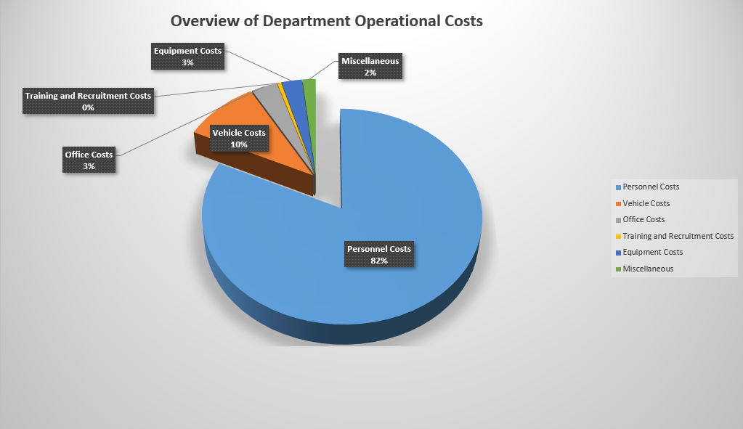

DEPARTMENT ORGANIZATIONAL CHART

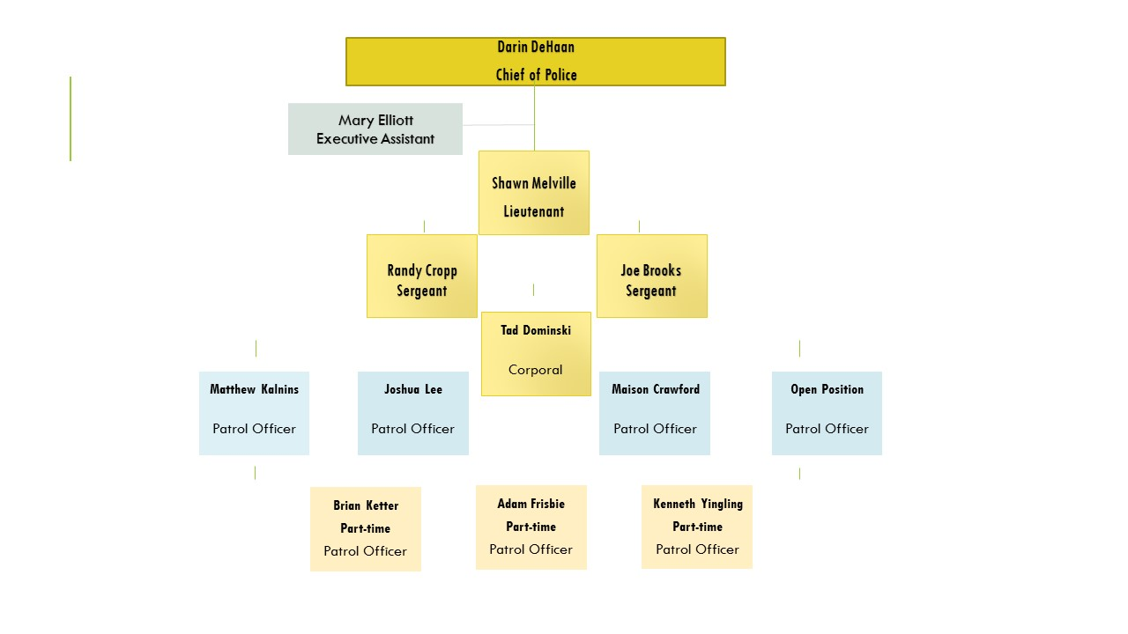

EMPLOYEES

ACADEMY GRADUATION

Sgt. Brooks and Chief DeHaan were honored to attend the Police Academy graduation for Officer Josh Lee on 06-14-19. Officer Lee completed his FTO period and is now on his own serving the community.
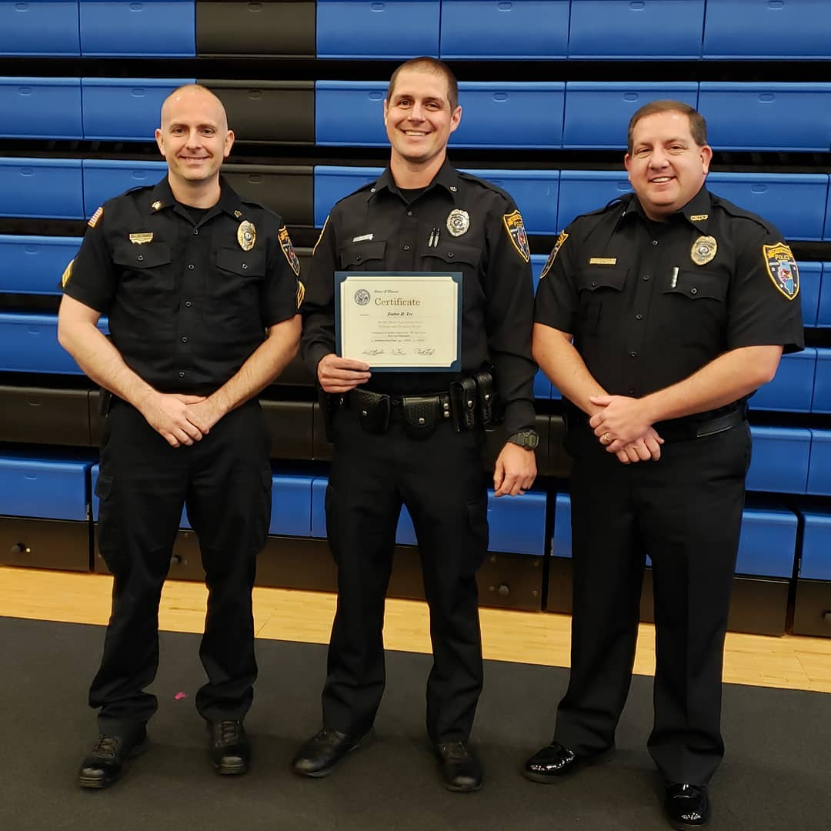
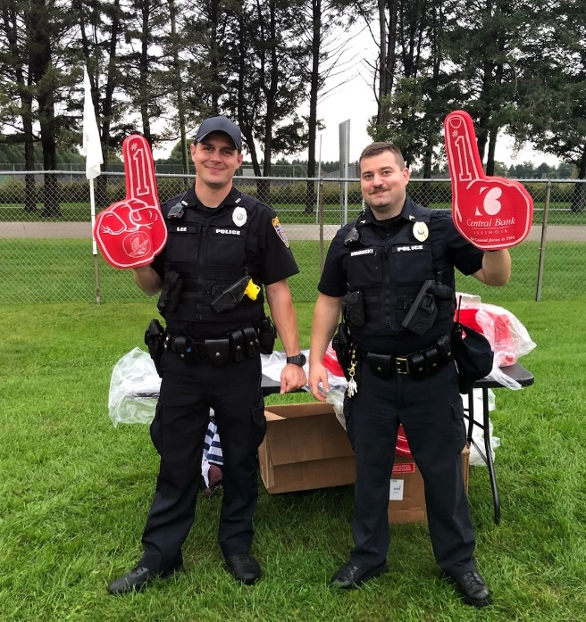

NEW EMPLOYEES

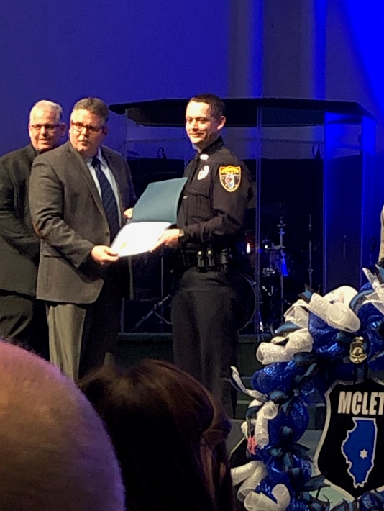
Maison Crawford was hired on 08/13/2019 to replace Officer Steve Mattas who accepted a position with St. Charles, IL Police Dept. Officer Crawford attended the Macon County Law Enforcement Center for 14 weeks for the police academy. He graduated on 11/22/2019 and is currently in the Phase II of the Field Training Program.

PART-TIME OFFICER

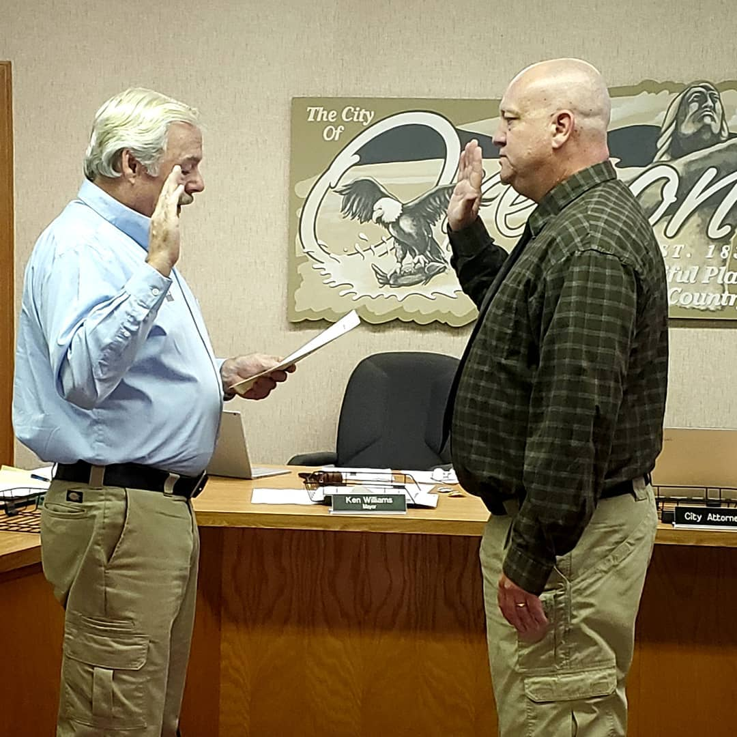
September 25th, 2019

Mayor Williams swore in Kenneth Yingling as a part-time police officer. Officer Yingling is a recent graduate of the academy and will help supplement police coverage at major events and regular patrol shifts. Welcome Officer Yingling!

COMMUNITY SERVICE OFFICER
In May of 2019 Commissioner Kurt Wilson and Chief DeHaan discussed adding a Community Service Officer for the City of Oregon for the summer.
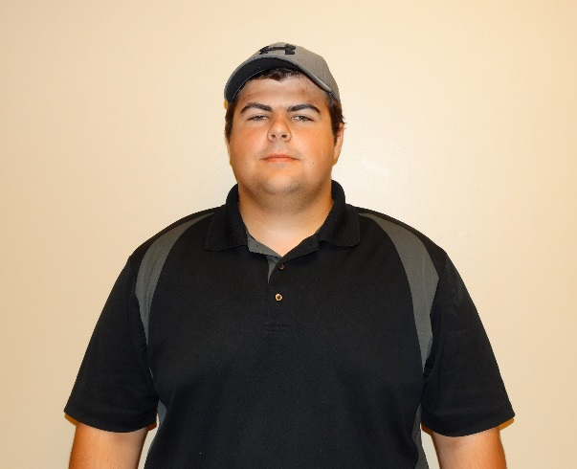
Shane Mowry was chosen for the position and began working for the City of Oregon in this capacity. Shane worked on parking issues in the business district, helped unlock cars, provided traffic control at accidents, helped at festivals, and provided many other services to our citizens in many other ways.
Shane handled over 60 ordinance violations over the summer and corrected the issues keeping Oregon a beautiful place to work and live. His last day of service was October 6th, helping us hang all the no parking signs for the Autumn on Parade.
"I know this position was challenging at times. Shane did a great job working and communicating with citizens and business owners to keep the town looking great. He handled many issues that would normally take a lot of time away from other duties of full-time officers. Thank you, Shane Mowry, for your service this summer to the City of Oregon. We wish you well on what’s next for your future." - Chief Darin DeHaan

RETIREMENTS/RESIGNATIONS

July 30th, 2019

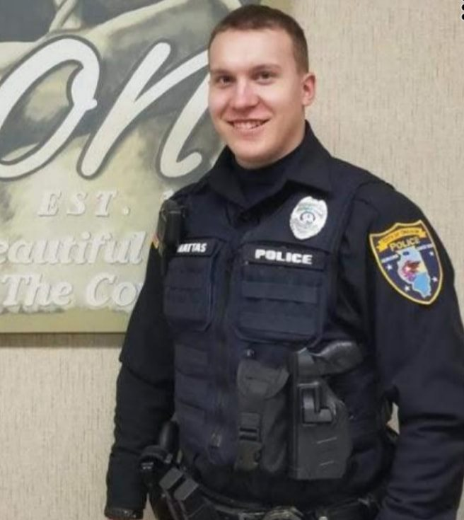
Officer Steve Mattas has accepted a position with another agency and resigned effective 07-26-2019 from Oregon PD. Thank you for your service to Oregon, Officer Mattas. “We were sad to see him go but wish him a safe and productive career with his new agency”. - Chief DeHaan

December 15th, 2019
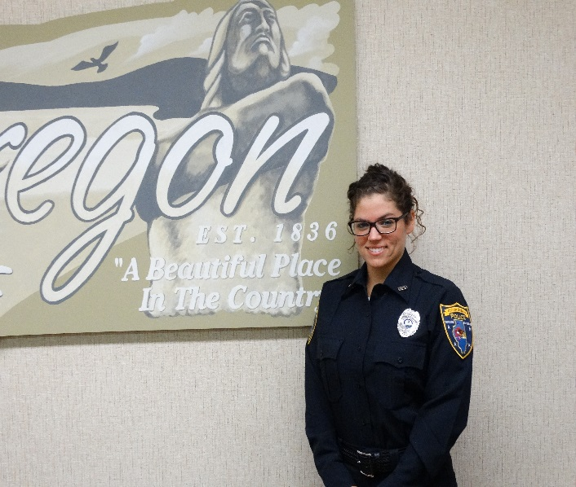
Officer Kristine Tesnow resigned from her position with the Oregon Police Department on 12/15/2019 and accepted a position with the Rockford Illinois Police Department. “We appreciate her year of service with our department and wish her a safe and successful career with her new agency.” – Chief DeHaan

AWARDS AND RECOGNITIONS

NATIONAL NIGHT OUT RECOGNITION

We are honored to receive recognition for our National Night Out event again this year. Thank you to Ofc. Matt Kalnins for all the work he put into the event. Thank you to everyone who attended and participated in 2019. We look forward to NNO 2020. **We would like to get more community participation and would like a few citizens to join an organization committee for the 2020 event. If you would be interested in helping, send us a Facebook message or call us and we will reach out to you as we get closer.

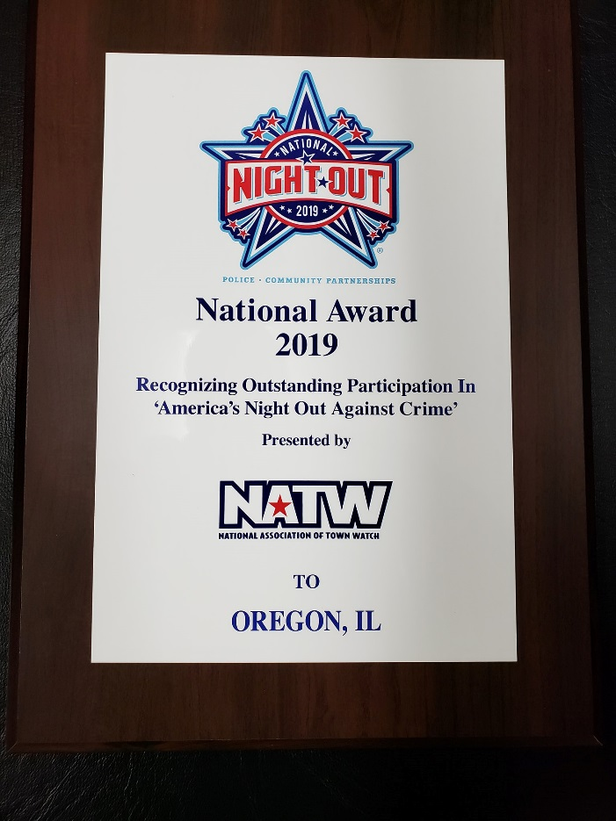

PROMOTIONS/SPECIAL ASSIGNMENTS

PROMOTION

September 25th, 2019

At the city council meeting Mayor Williams swore Officer Tad Dominski in. After a rigorous testing process Officer Dominski was promoted to the position of Corporal. He will take the role of on shift supervisor that Sgt. Cropp previously held before he moved to the SRO position.
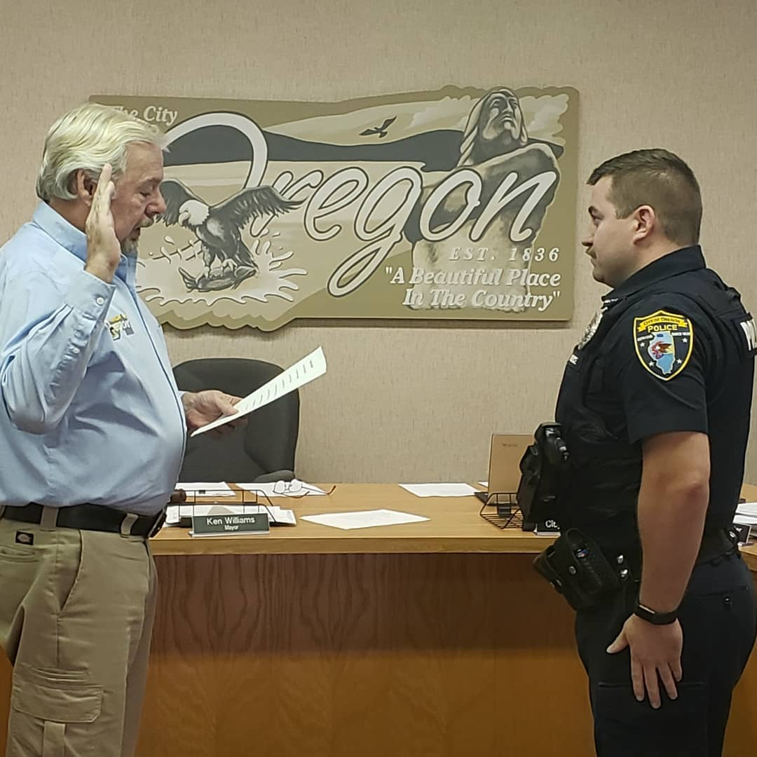

CRIME STATISTICS
The chart below is the Illinois UCR report for 2018 (the latest report). This shows a comparison of the total Index crimes reported to Ogle County, Byron PD, Mt. Morris PD, and Oregon PD.

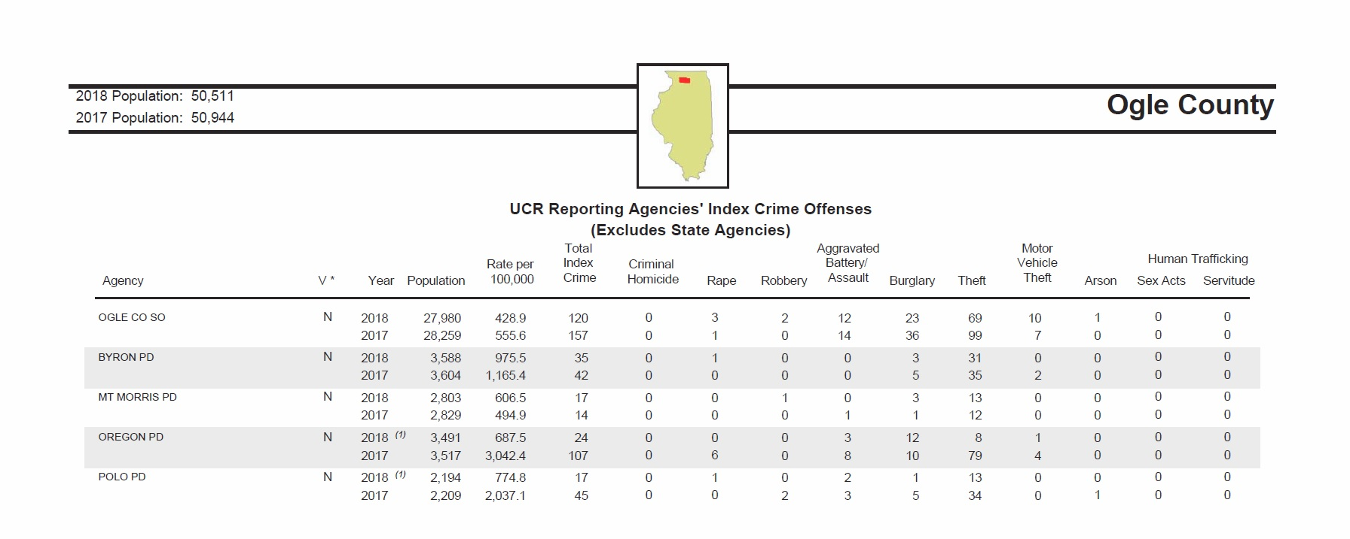
2016 – 2019 STATISTICAL COMPARATIVES

*Note these are crimes reported and tickets issued, not arrest and conviction statistics.

 | 2016 | 2017 | 2018 | 2019 | (+ or -)
Aggravated Battery | 1 | 3 | 5 | 5 | 0.00% | null
Battery | 15 | 23 | 14 | 26 | 86.00% | increase
Domestic Battery | 20 | 26 | 31 | 23 | 26.00% | decrease
Aggravated Assault | 3 | 1 | 0 | 1 | 100.00% | increase
Fraud | 10 | 12 | 9 | 10 | 11.00% | increase
ID Theft | 7 | 2 | 5 | 5 | 0.00% | null
Credit Card Fraud | 1 | 1 | 3 | 4 | 33.00% | increase
Theft Less Than $500 | 43 | 37 | 28 | 19 | 32.00% | decrease
Theft More Than $500 | 8 | 25 | 8 | 9 | 12.00% | increase
Retail Theft | 7 | 6 | 12 | 5 | 58.00% | decrease
Burglary | 10 | 4 | 11 | 7 | 36.00% | decrease
Residential Burglary | 6 | 5 | 6 | 5 | -16.67% | decrease
Burglary to Motor Vehicle | 26 | 5 | 2 | 7 | 250.00% | increase
Criminal Damage to Property | 18 | 23 | 16 | 19 | 18.00% | increase
Criminal Dmg to State Sup Prop | 2 | 4 | 2 | 0 | 100.00% | decrease
Criminal Trespass to Land | 10 | 7 | 0 | 9 | 900.00% | increase
Criminal Trespass to Vehicle | 17 | 8 | 1 | 8 | 700.00% | increase
Criminal Trespass to Residence | 14 | 5 | 10 | 2 | 80.00% | decrease
Criminal Sexual Abuse | 1 | 2 | 3 | 5 | 66.00% | increase
Agg Criminal Sexual Abuse | 0 | 1 | 0 | 0 | 0.00% | null
Criminal Sexual Assault | 2 | 5 | 2 | 2 | 0.00% | null
Agg Criminal Sexual Assault | 0 | 1 | 0 | 0 | 0.00% | null
Runaway | 17 | 5 | 3 | 2 | 33.00% | decrease
Disorderly Conduct | 30 | 36 | 38 | 32 | 16.00% | decrease
Uninsured Motor Vehicle | 13 | 13 | 16 | 28 | 75.00% | increase
No Driver's License | 3 | 9 | 10 | 10 | 0.00% | null
Susp/Revoked D.L. | 22 | 23 | 45 | 44 | 2.22% | decrease
DUI Alcohol/Drugs | 12 | 16 | 13 | 21 | 61.50% | increase

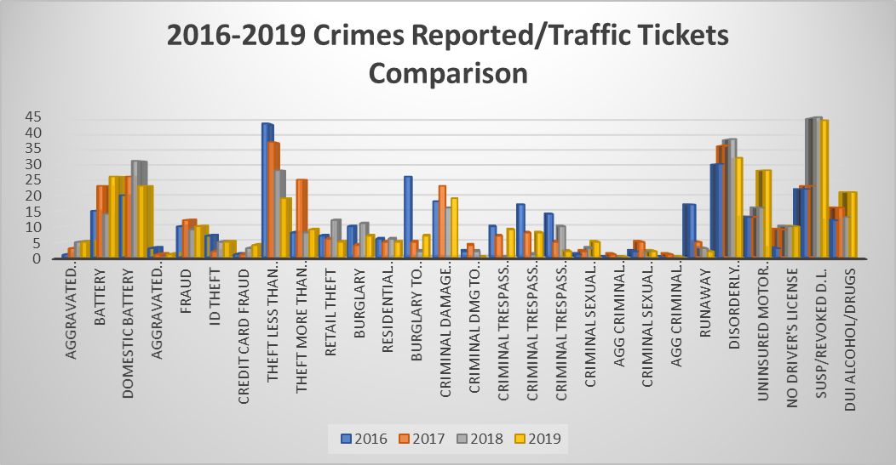
CRIMES REPORTED/TRAFFIC TICKET COMPARISON CHART

2019 COMMUNITY INTERACTION PROGRAMS

May 2019 COP ON A ROOFTOP

Oregon Officer Kristine Tesnow braved bad weather and joined the Rochelle Illinois Police and area Law Enforcement Agencies for Cop On A Rooftop fundraiser for Special Olympics at Rochelle Dunkin' Donuts. Thank you for the invite Rochelle Illinois Police and thank you everyone who gave money and participated in this fundraiser.

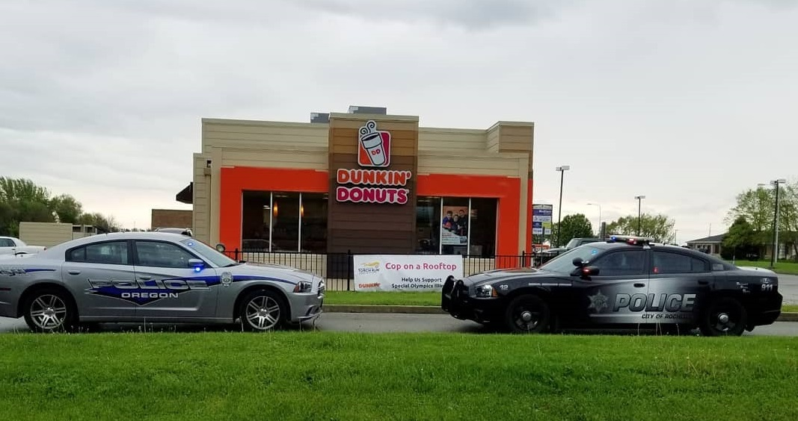

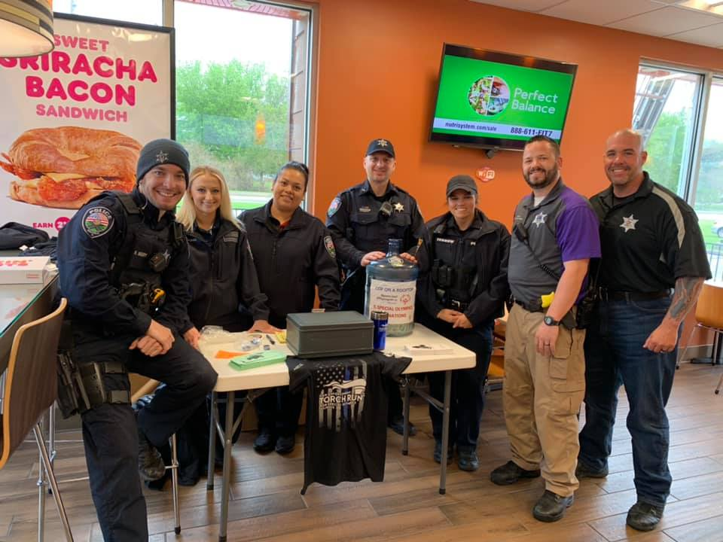

AUGUST 6^{TH,} 2019 NATIONAL NIGHT OUT

Our National Night Out was a great success again this year. Several of the area’s first responder agencies participated including the Oregon Fire Protection District and the Illinois State Police. The Oregon Street Department supplied a vehicle for the public to check out. We had an appearance by Eddy the Eagle this year and did a presentation of firearm safety. The Oregon Fire Protection District Demonstrated their new CPR tool.

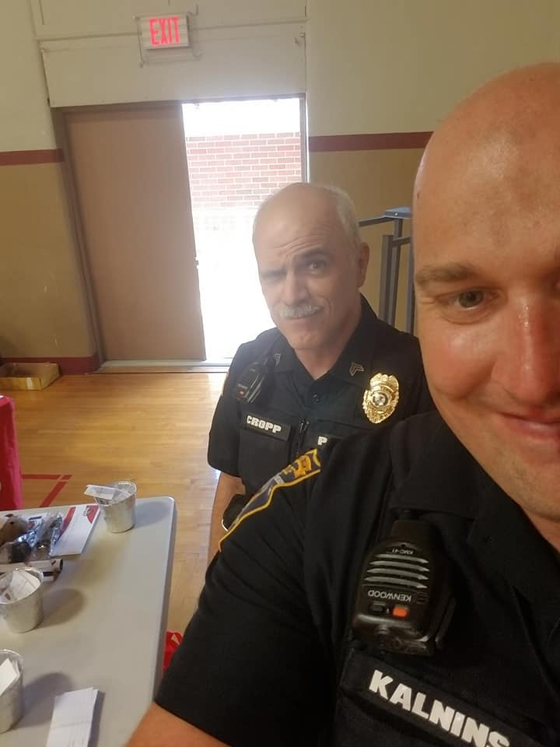
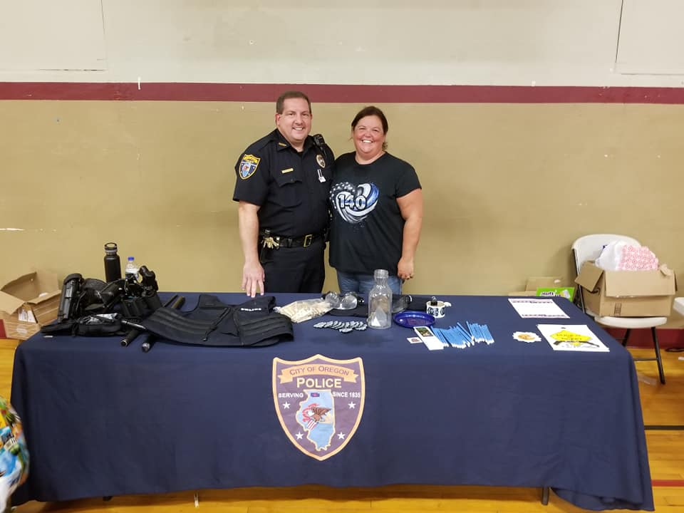

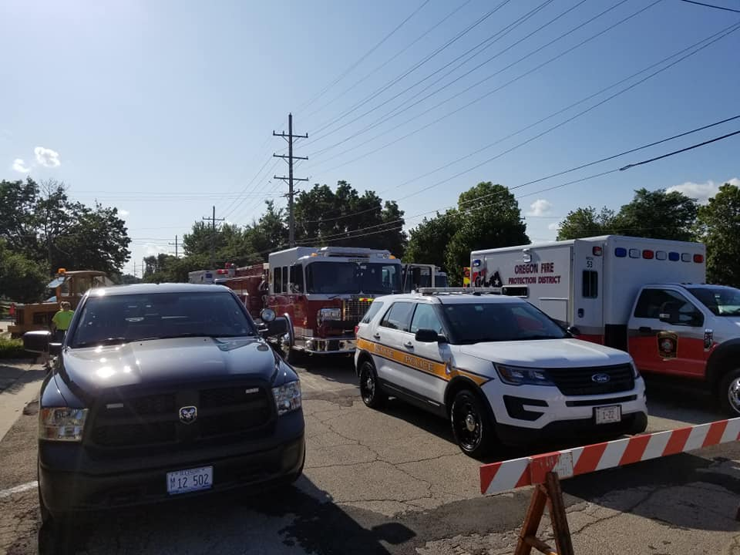

OCTOBER PARTNERSHIP WITH OGLE COUNTY SHERIFFS DEPARTMENT

CALENDAR SALE FOR SCOTT’S LAW EDUCATION
This year the Ogle County Sheriff's Office has partner with several agencies for their 2020 annual calendar fundraiser. Our department is featured in July.
The Oregon Police Department had a goal of selling 50 calendars this year to support a great cause.
The funds will go towards Scott's Law education in Ogle County.
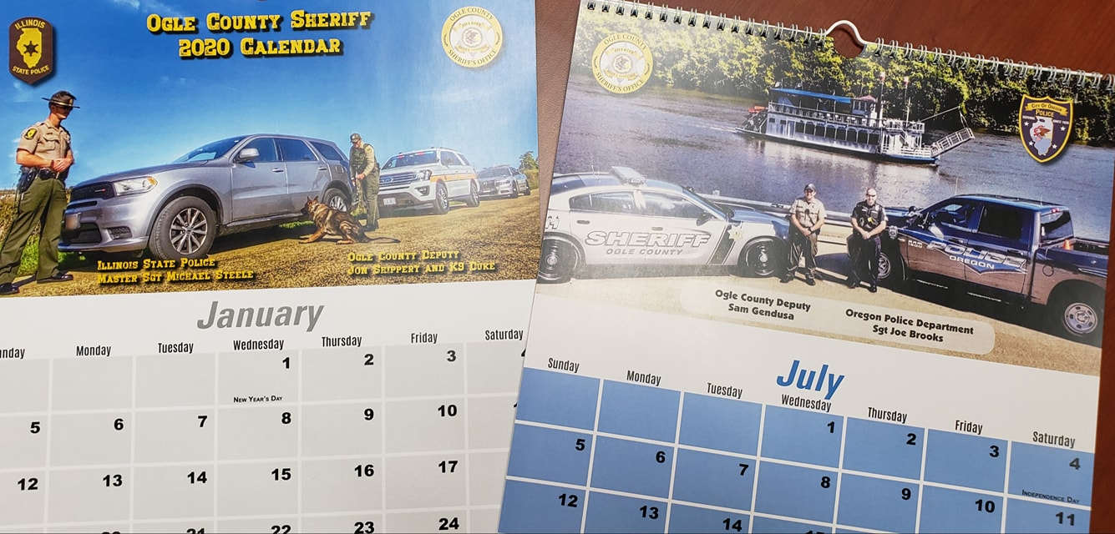

NOVEMBER/DECEMBER 2019: NO SHAVE NOVEMBER

AND DOUBLE DOWN DECEMBER
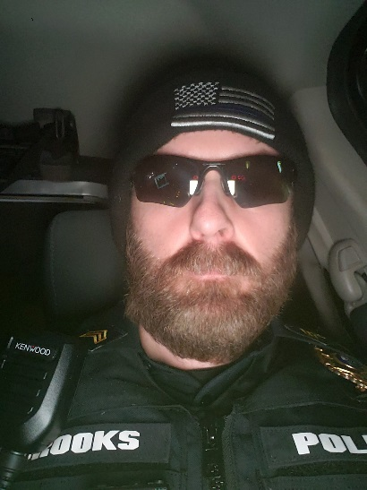
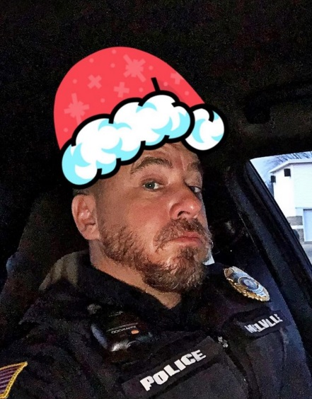
Members of the Oregon Police Department participated in No Shave November. This year we chose to donate the proceeds to a local woman who has been battling breast cancer. Several officers participated in double down December and donated the funds to a local family in need for Christmas presents and Christmas dinner.

JUNE 2019 SPECIAL OLYMPICS TORCH RUN

Members of the Oregon Police Department Joined area law enforcement officers in the
Annual Special Olympics Torch Run.

2019 SPECIAL OLYMPICS POLAR PLUNGE

Oregon Officer Matthew Kalnins joined other Ogle County 1st Responders participated in the annual Special Olympics Polar Plunge at Rock Cut State Park.

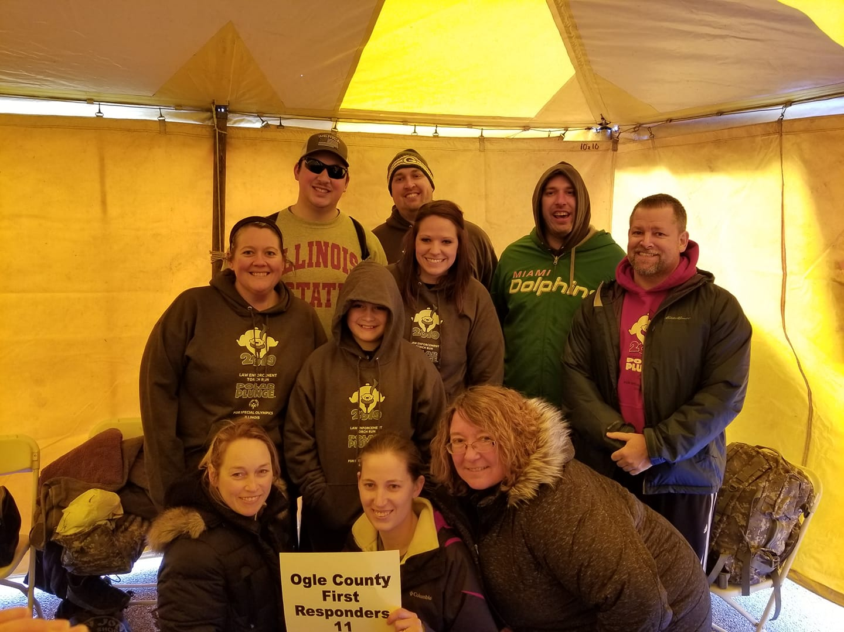

DECEMBER 2019: TOYS FOR TOTS

The Oregon Police Department was a drop off site for Toys for Tots this year. We were glad to participate in this great cause!

DECEMBER 2019: SHOP WITH A COP
The Oregon Police Department participated in the Shop with a Cop held at Freeport Walmart.

2019 SPECIAL PROGRAMS AND GRANTS

In Car Camera Grant

The Oregon Police Department received an in-car camera grant through the state of Illinois Law Enforcement Training and Standards Board. This grant provided approximately $10,000 in funds to help up purchase three new in car video cameras. One replaced a nonfunctioning camera and two were installed into squads which did not currently have cameras. We are thankful for the grant as these cameras provide essential evidence as well as officer protection from frivolous and unfounded complaints.

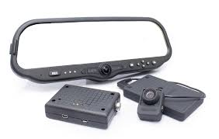

Mobile Field Force

Officer Kalnins continues to train and participate with the ILEAS Mobile Field Force. His training and participation are invaluable for the City of Oregon.

TRAINING

We continue to work on ways to provide cost effective and highly successful training for our officers. Officer Matt Kalnins and Officer Tad Dominski are now both certified Taser Instructors. This allows us to provide the required taser recertification training inhouse.

Officer Matt Kalnins is also a certified control tactics instructor which allows us to work on control tactic techniques and develop effective use of force training for our agency.

We are also utilizing more online training courses, so our officers can continue to train, but limits our travel and time expenses.

The Oregon Police Department continues to proactively train and educate all our employees. Officers are required to receive a minimum of 40 hours of training each year.

SOCIAL MEDIA

Social media continues to provide a valuable means of assisting the department and its
employees with community outreach, problem-solving, investigative, crime prevention
and related objectives. We provide crime trend information and receive valuable tips from citizens through our social media.

In 2019, the department’s Instagram account has 278 followers, Twitter account has 987 followers up from 940 followers while the department’s Facebook account has amassed 3425 followers up from 2,949 last year.

2019 POLICE DEPARTMENT CONSTRUCTION
